# Tutorial 4.1

1. Stimulated the **Hodgkin-Huxley model** for 0.35s with required parameters: the membrane potential stabilizes at -70.2mV
2. Produced a vector for the applied current that has a baseline of zero and steps up to 0.22nA for a duration of 100ms beginning at a time of 100ms. Plotted the applied current on an upper graph and the membrane potential’s response on a lower graph of the same figure. No spikes but oscillations occur.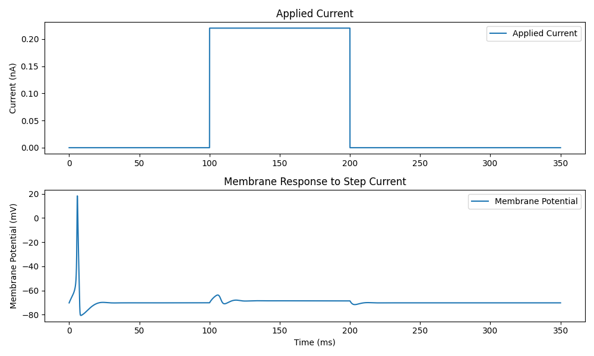
3. Designed the applied current to be a series of 10 pulses, each of 5ms duration and 0.22nA amplitude.

As shown on the next page, these are the results of different lengths of intervals (10ms, 11ms, 12ms and 25ms respectively) It seems that the spikes will occur only during specific lengths of applied current separation. I tried multiple times and spikes took place within 10ms to 14ms.

1. Set the baseline current to be 0.6nA. Set the initial conditions as 𝑉(0) = −0.065V, 𝑚(0) = 0.05, ℎ(0) = 0.5, 𝑛(0) = 0.35. Applied a series of 10 inhibitory pulses to bring the applied current to zero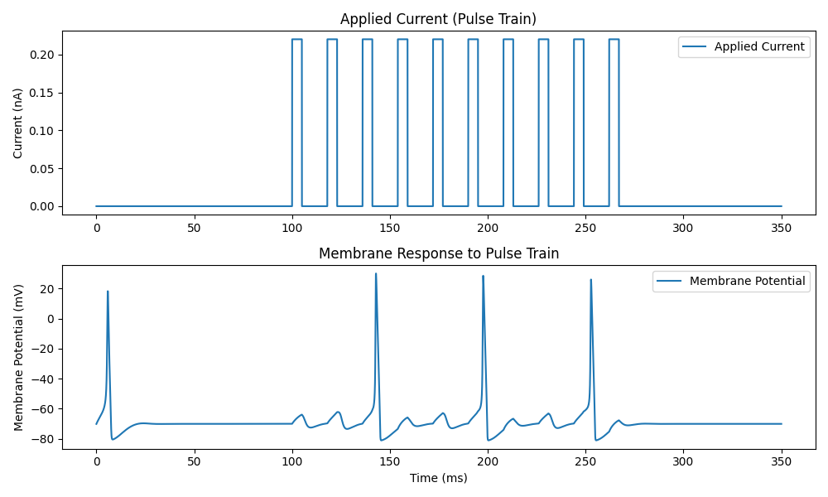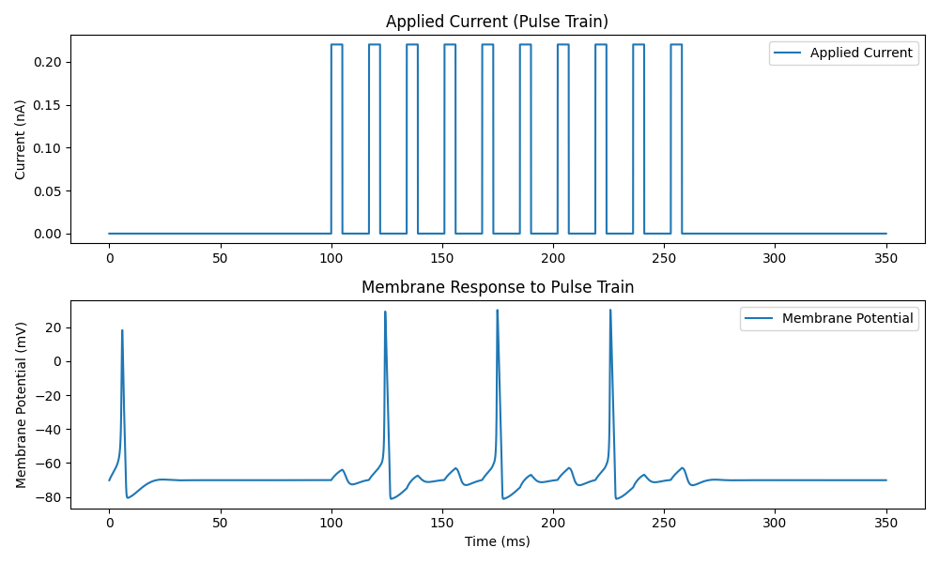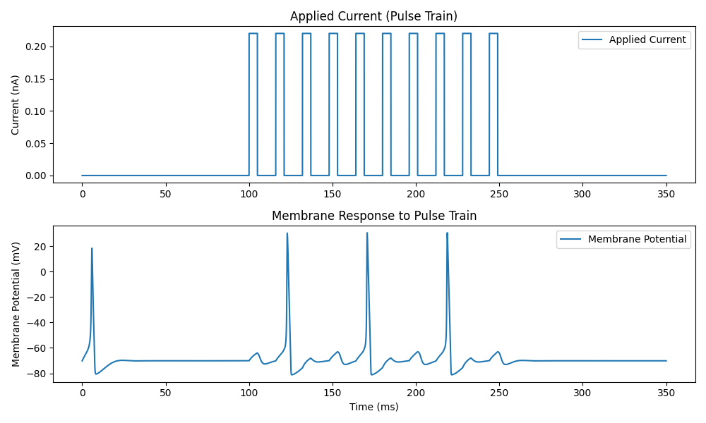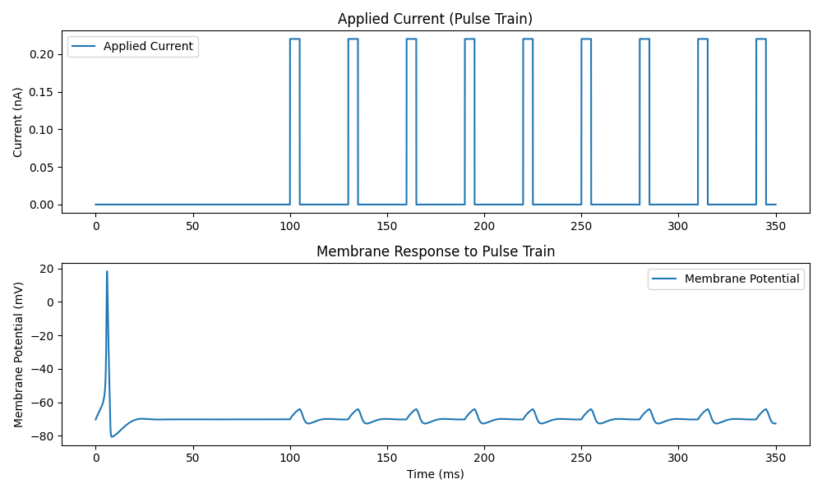

After each inhibitory pulses, a spike in membrane potential occurs.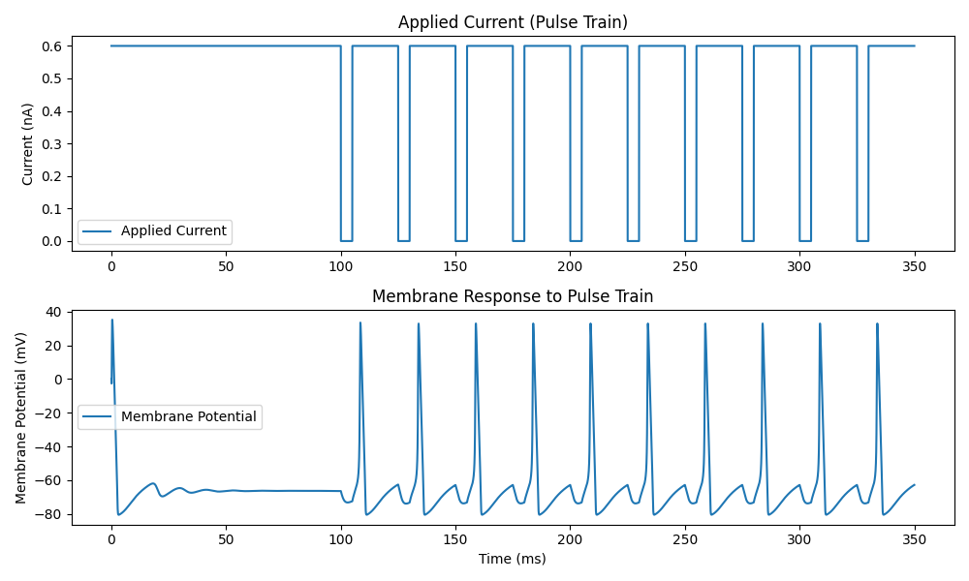

1. Set the baseline current to 0.65nA. Increased the excitatory current to 1nA for a 5ms pulse at the time point of 100ms.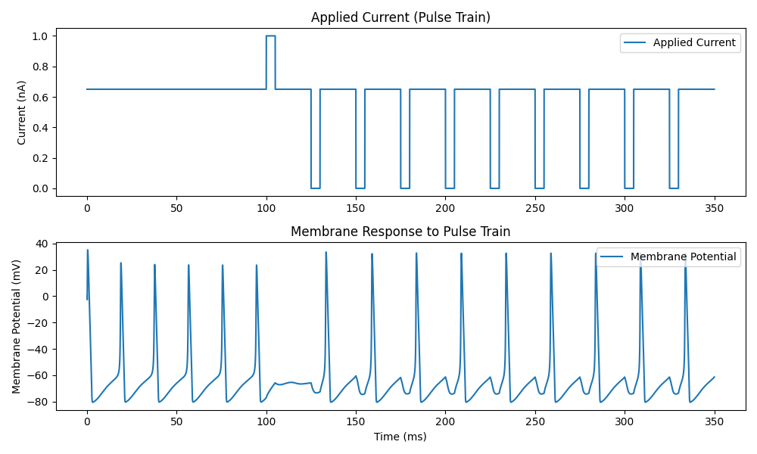

I observed a gap after 100ms where no spikes took place. In contrast to part d, spikes are present also before 100ms where only constant baseline current was applied.

1. Repeat e) with the baseline current of 0.65nA, but set the initial conditions as 𝑉(0) = −0.065V, 𝑚(0) = 0, ℎ(0) = 0, 𝑛(0) = 0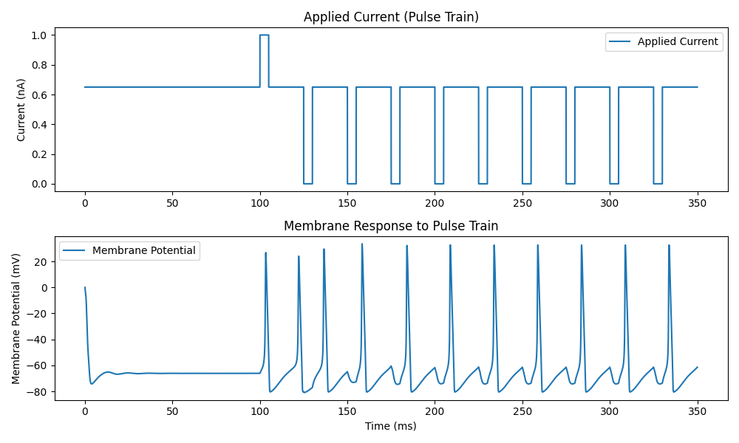

Compared to part e, the set of initial conditions to 0 eliminates the spikes before current pulses were introduced.